# Using Web3.js to Interact with Smart Contracts.

* Make sure you have web3 installed and install truffle and verify installation.

Install command:

npm install -g truffle

check:

truffle version

* Create a new folder and initialize truffule

mkdir MyTruffleProject

cd MyTruffleProject

truffle init

* We get to see truffle-config.js  
  In that uncomment the following part and make the required changes  
  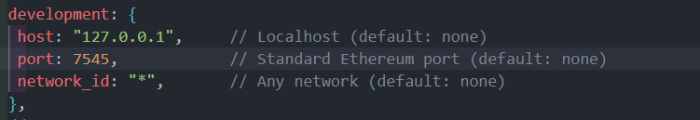

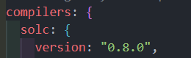

* Create a solidity file which will be your contract and put in MyTruffleProject/contracts

SimpleStorage.sol:

// SPDX-License-Identifier: MIT

pragma solidity ^0.8.0;

contract SimpleStorage {

uint256 public storedData;

function set(uint256 x) public {

storedData = x;

}

function get() public view returns (uint256) {

return storedData;

}

}

* Compile the file using the following command

sudo truffle compile for windows truffle compile

* In MyTruffleProject/migrations create a file “2_deploy_contracts.js” with following code.  
  2_deploy_contracts.js:  
  const SimpleStorage = artifacts.require("SimpleStorage");

module.exports = function (deployer) {

deployer.deploy(SimpleStorage);

};

* Deploy contracts using the following command in parent directory  
  truffle migrate --network development
* Now create a ‘.js’ file in MyTruffleProject Folder with the following code  
  testContract.js :  
  const {Web3} = require('web3');

const web3 = new Web3('http://127.0.0.1:7545'); // Ganache RPC server address

// Get the contract ABI and address from the build files

const contractABI = /* ABI generated by Truffle */;

const contractAddress = /* Deployed contract address */;

const simpleStorage = new web3.eth.Contract(contractABI, contractAddress);

// Interact with the contract

async function interactWithContract() {

const accounts = await web3.eth.getAccounts();

const receipt = await simpleStorage.methods.set(42).send({ from: accounts[0] });

console.log('Transaction receipt:', receipt);

const value = await simpleStorage.methods.get().call();

console.log('Stored value:', value);

}

interactWithContract();

* You can find the ABI in MyTruffleProject/Build/SimpleStorage.json
* Change the contractAddress to the address you got while compiled in quotes
* Run using the command node testContract.js